Fujifilm Business Innovation (China) Co., Ltd. Apeos C3070, Apeos C6580, Apeos C5570 printers have unauthorized access vulnerabilities

1. Vulnerability Description

Fujifilm Business Innovation (China) Co., Ltd. is a Chinese subsidiary of Fujifilm Business Innovation, providing products and services such as intelligent color digital multifunction machines, laser printers/all-in-one machines, and production digital printing systems. Its peos C3070, Apeos C6580, and ApeosC5570 printers have unauthorized access vulnerabilities.

2. Impact of the vulnerability

The printer can be restarted, scanned, shut down, etc.

3. Vulnerability Location

[https://220.67.79.153/home/index.html#hashHome](https://220.67.79.153/home/index.html" \l "hashHome)

[https://203.255.38.219/home/index.html#hashHome](https://203.255.38.219/home/index.html" \l "hashHome)

http://1.232.247.244/home/index.html#hashHome

https://1.232.247.35/home/index.html#hashHome

https://1.232.247.52/home/index.html#hashHome

https://211.51.38.102/home/index.html#hashHome

https://210.115.236.245/home/index.html#hashHome

https://211.51.38.117/home/index.html#hashHome

http://211.171.228.136/home/index.html#hashHome

<https://211.51.38.113/home/index.html#hashHome>

4. Vulnerability Reproduction

Just visit:

[https://220.67.79.153/home/index.html#hashHome](https://220.67.79.153/home/index.html" \l "hashHome)

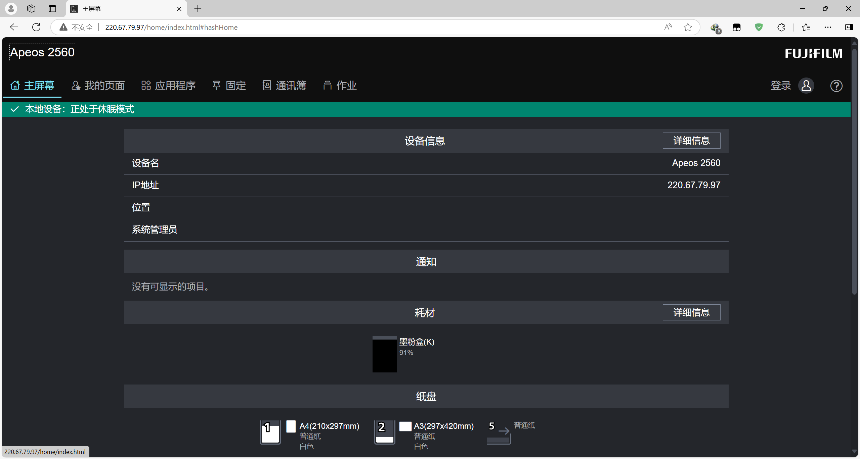

The printer can be restarted, scanned, shut down, etc.

[https://203.255.38.219/home/index.html#hashHome](https://203.255.38.219/home/index.html" \l "hashHome)

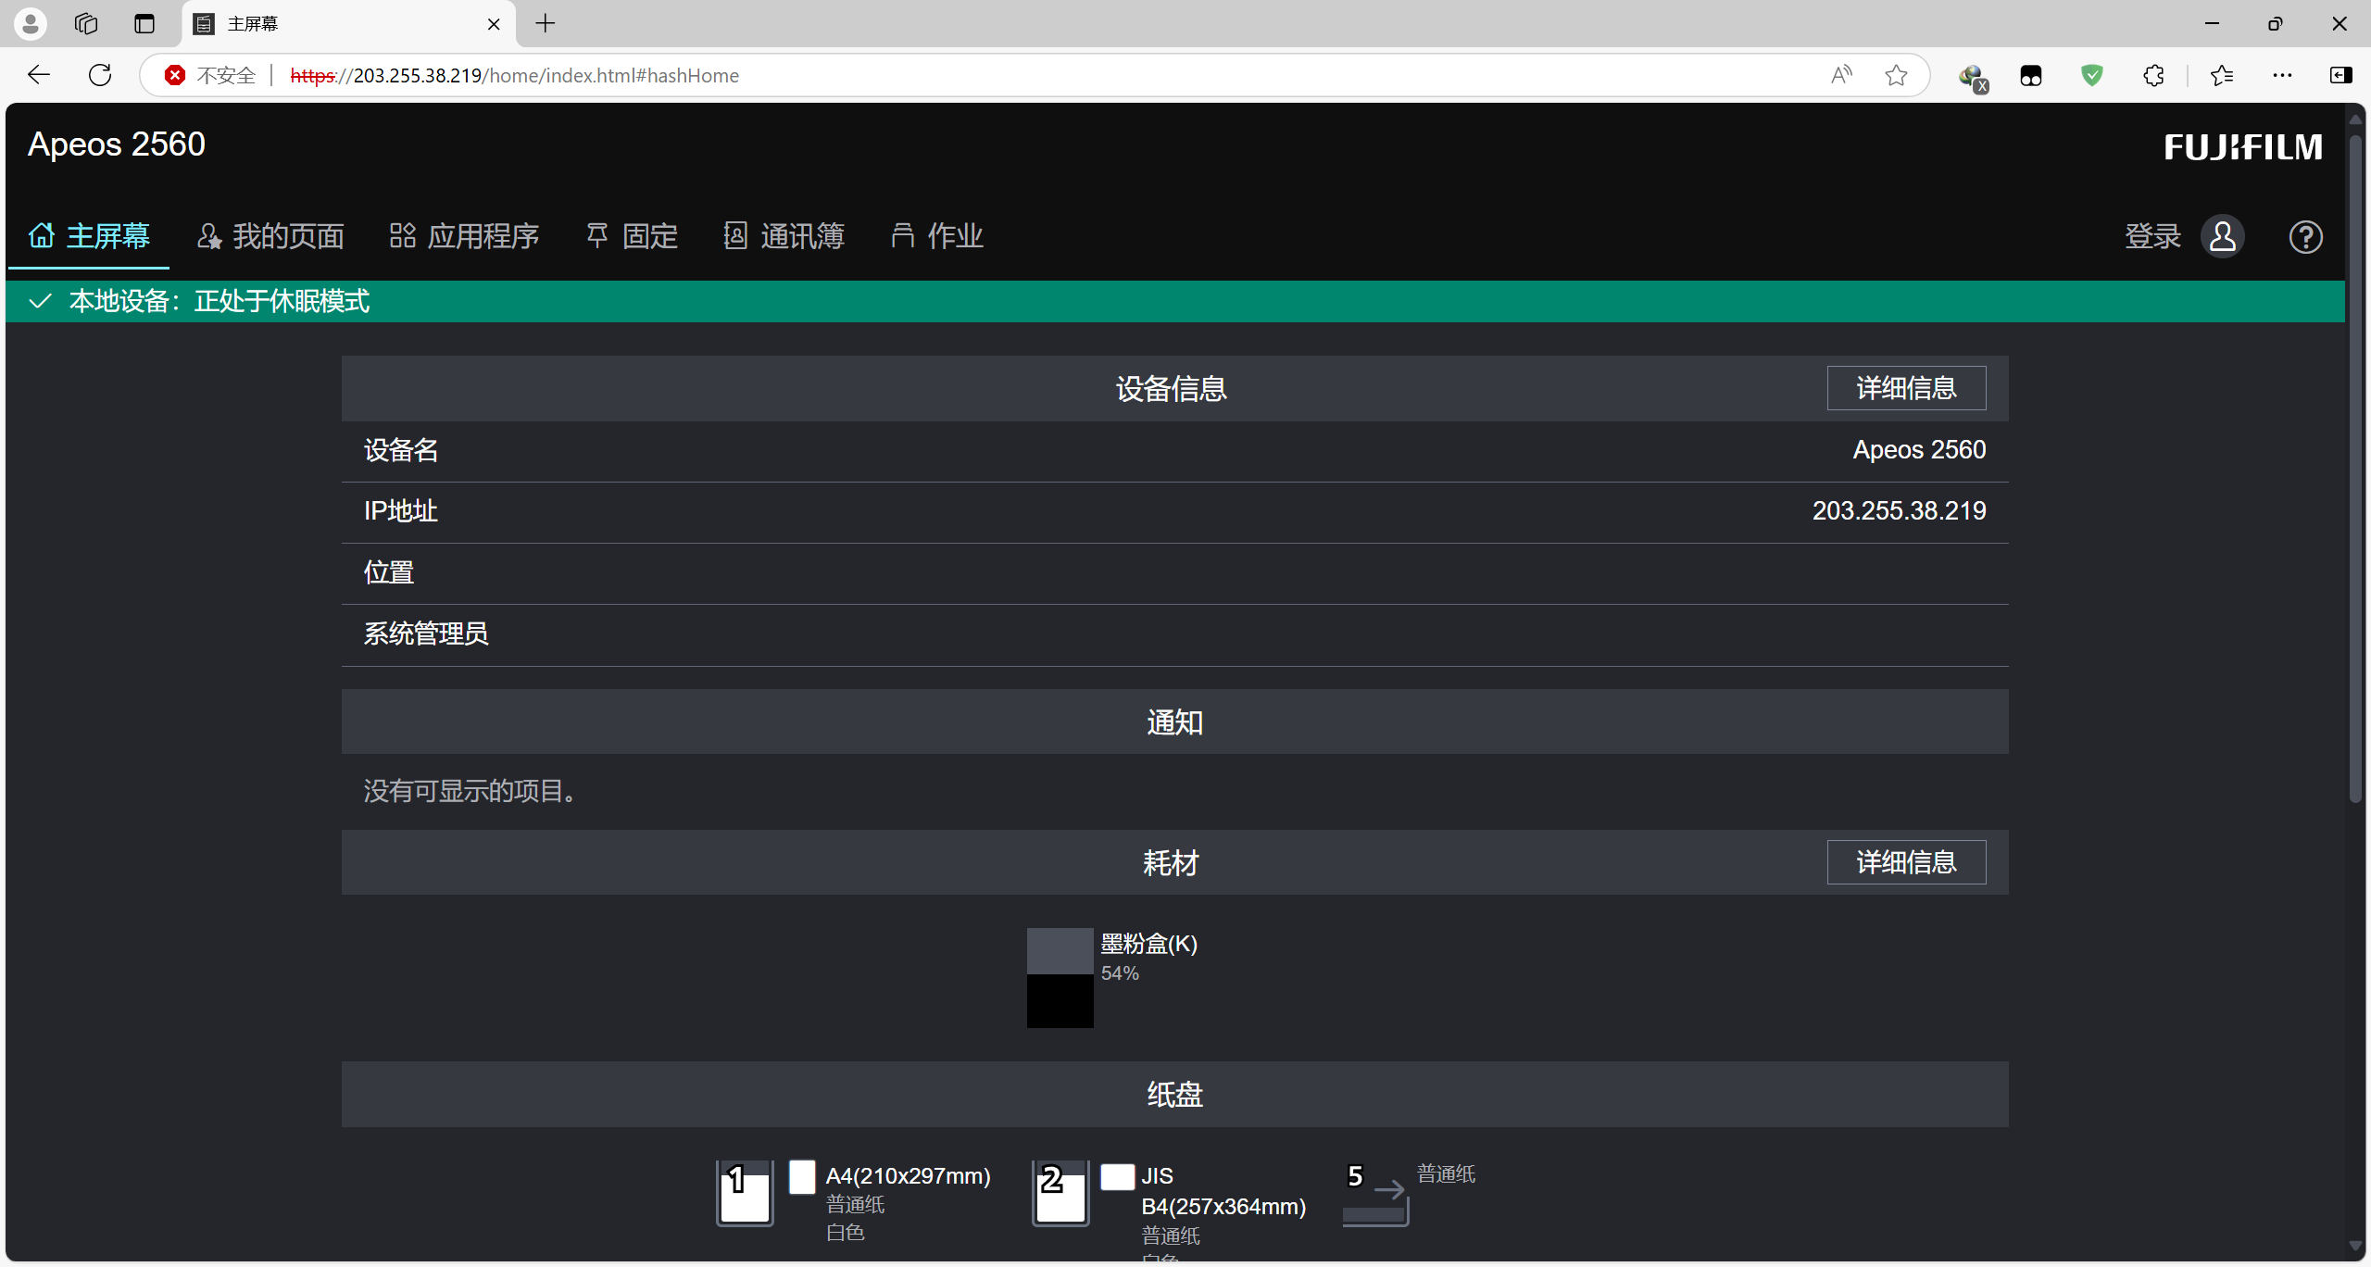

The printer can be restarted, scanned, shut down, etc.

http://1.232.247.244/home/index.html#hashHome

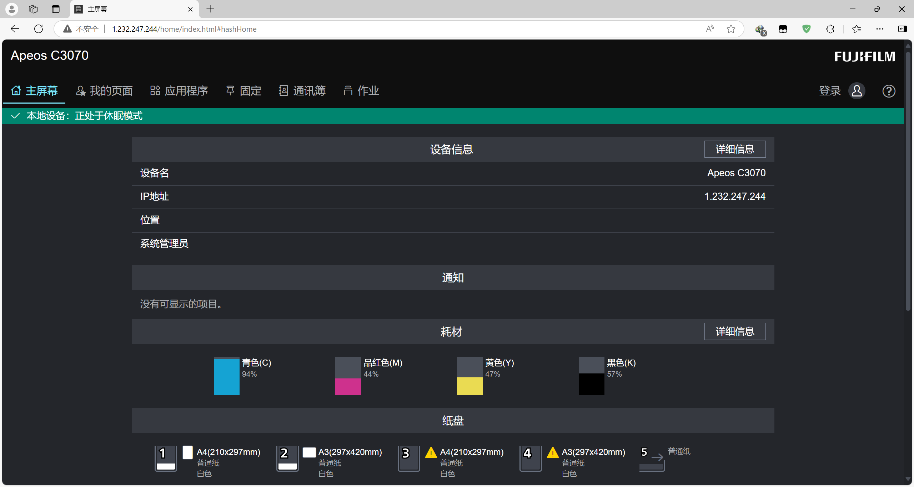

The printer can be restarted, scanned, shut down, etc.

https://1.232.247.35/home/index.html#hashHome

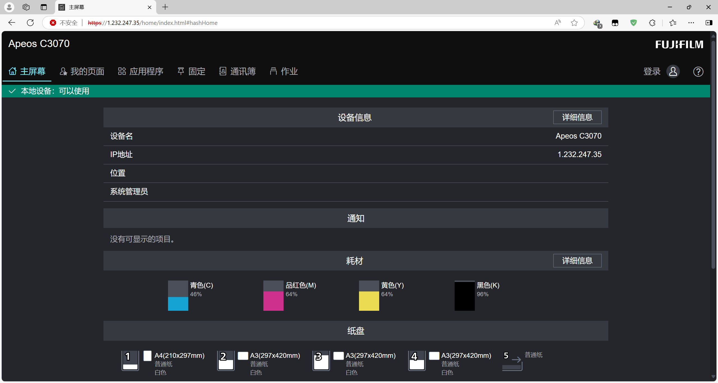

The printer can be restarted, scanned, shut down, etc.

https://1.232.247.52/home/index.html#hashHome

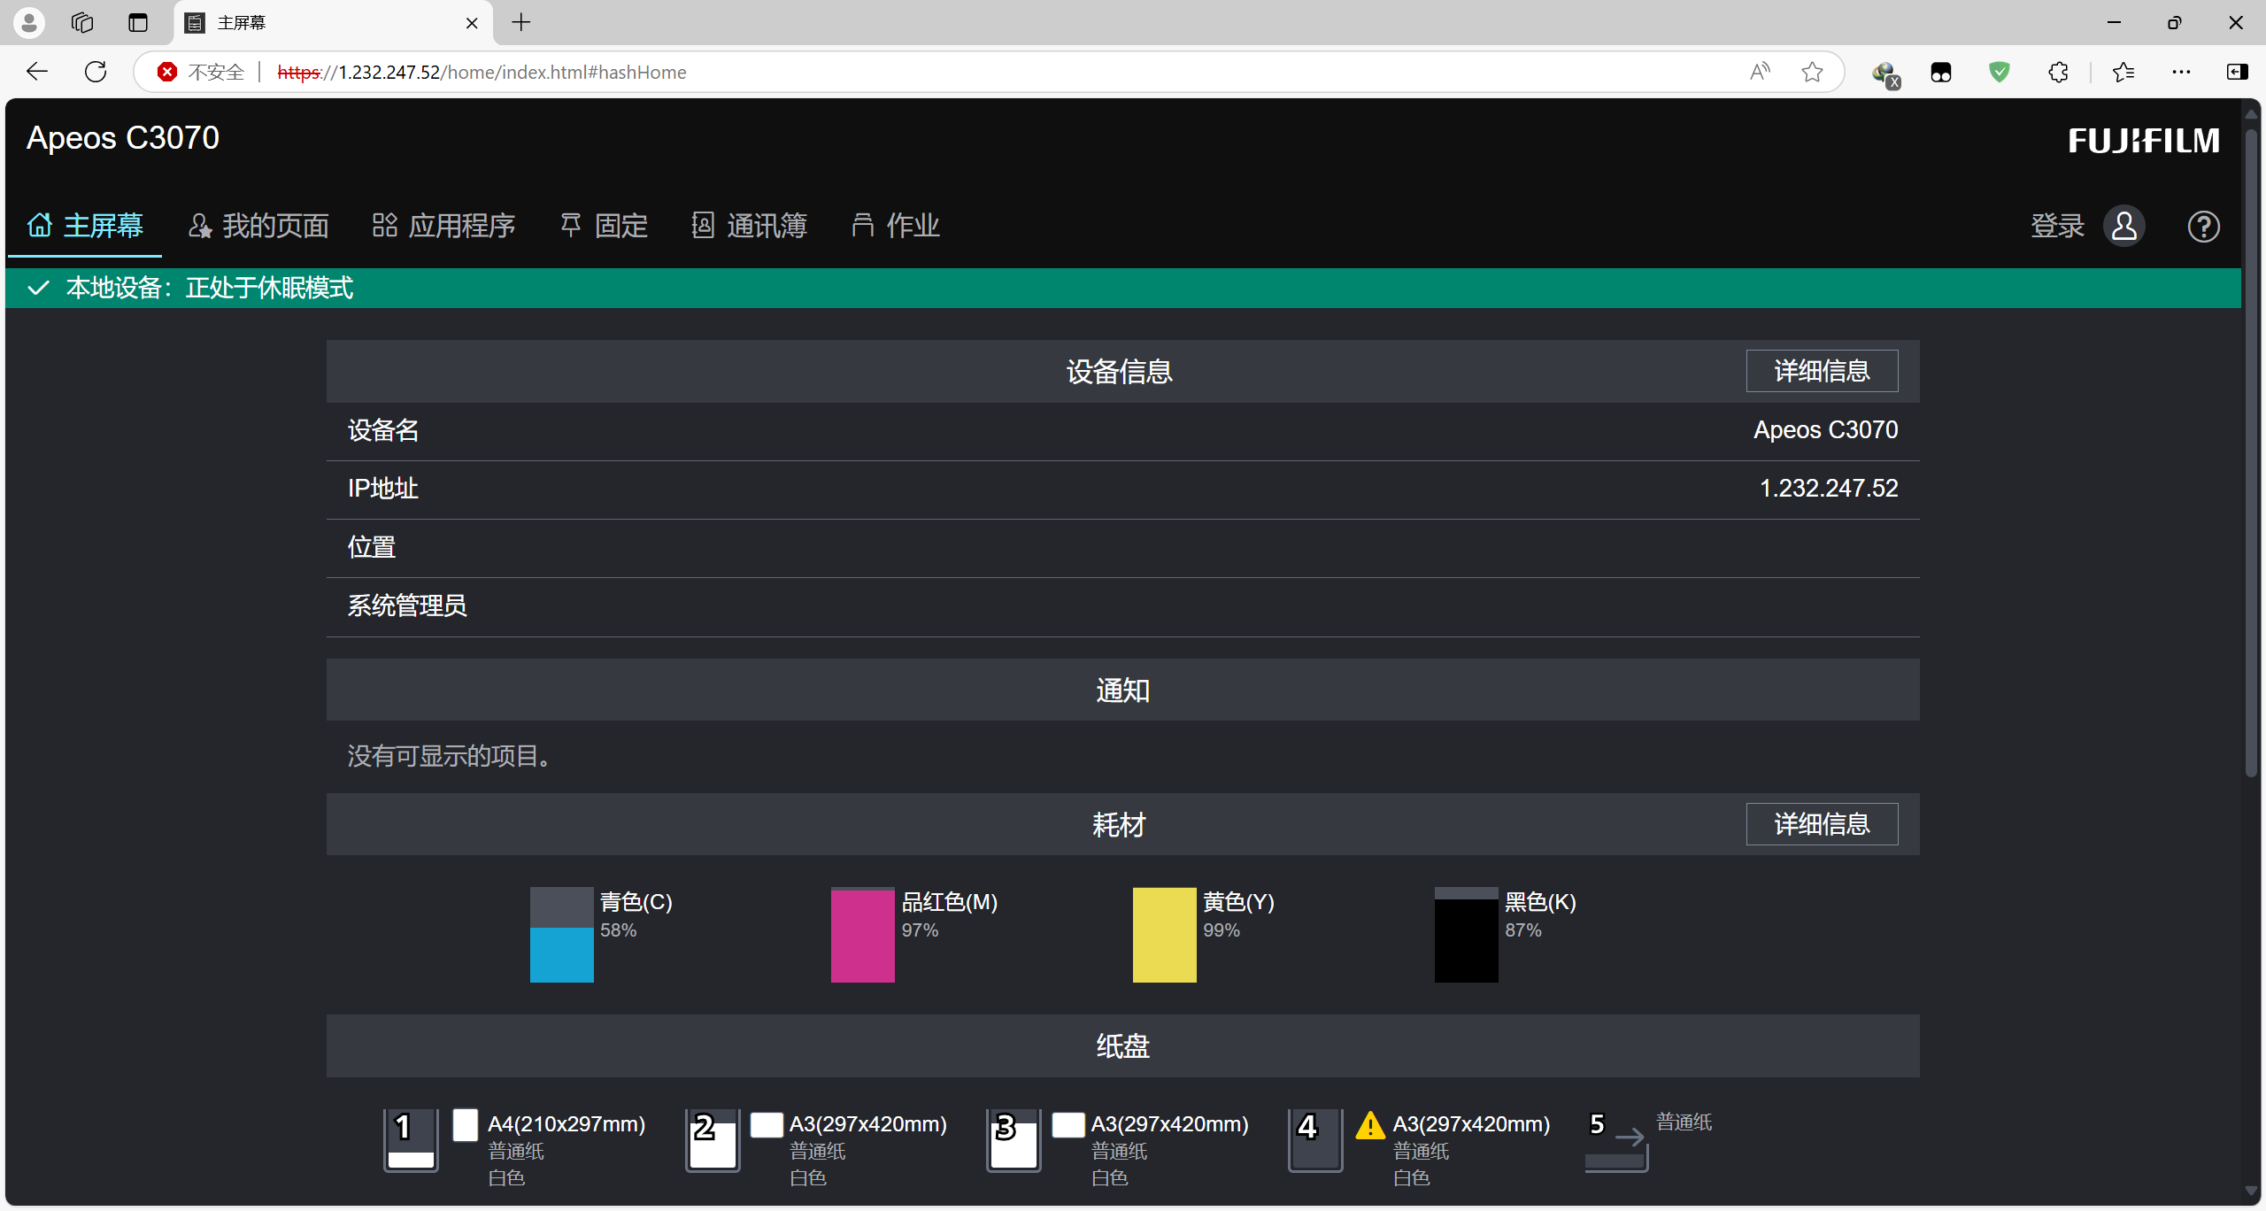

The printer can be restarted, scanned, shut down, etc.

https://211.51.38.102/home/index.html#hashHome

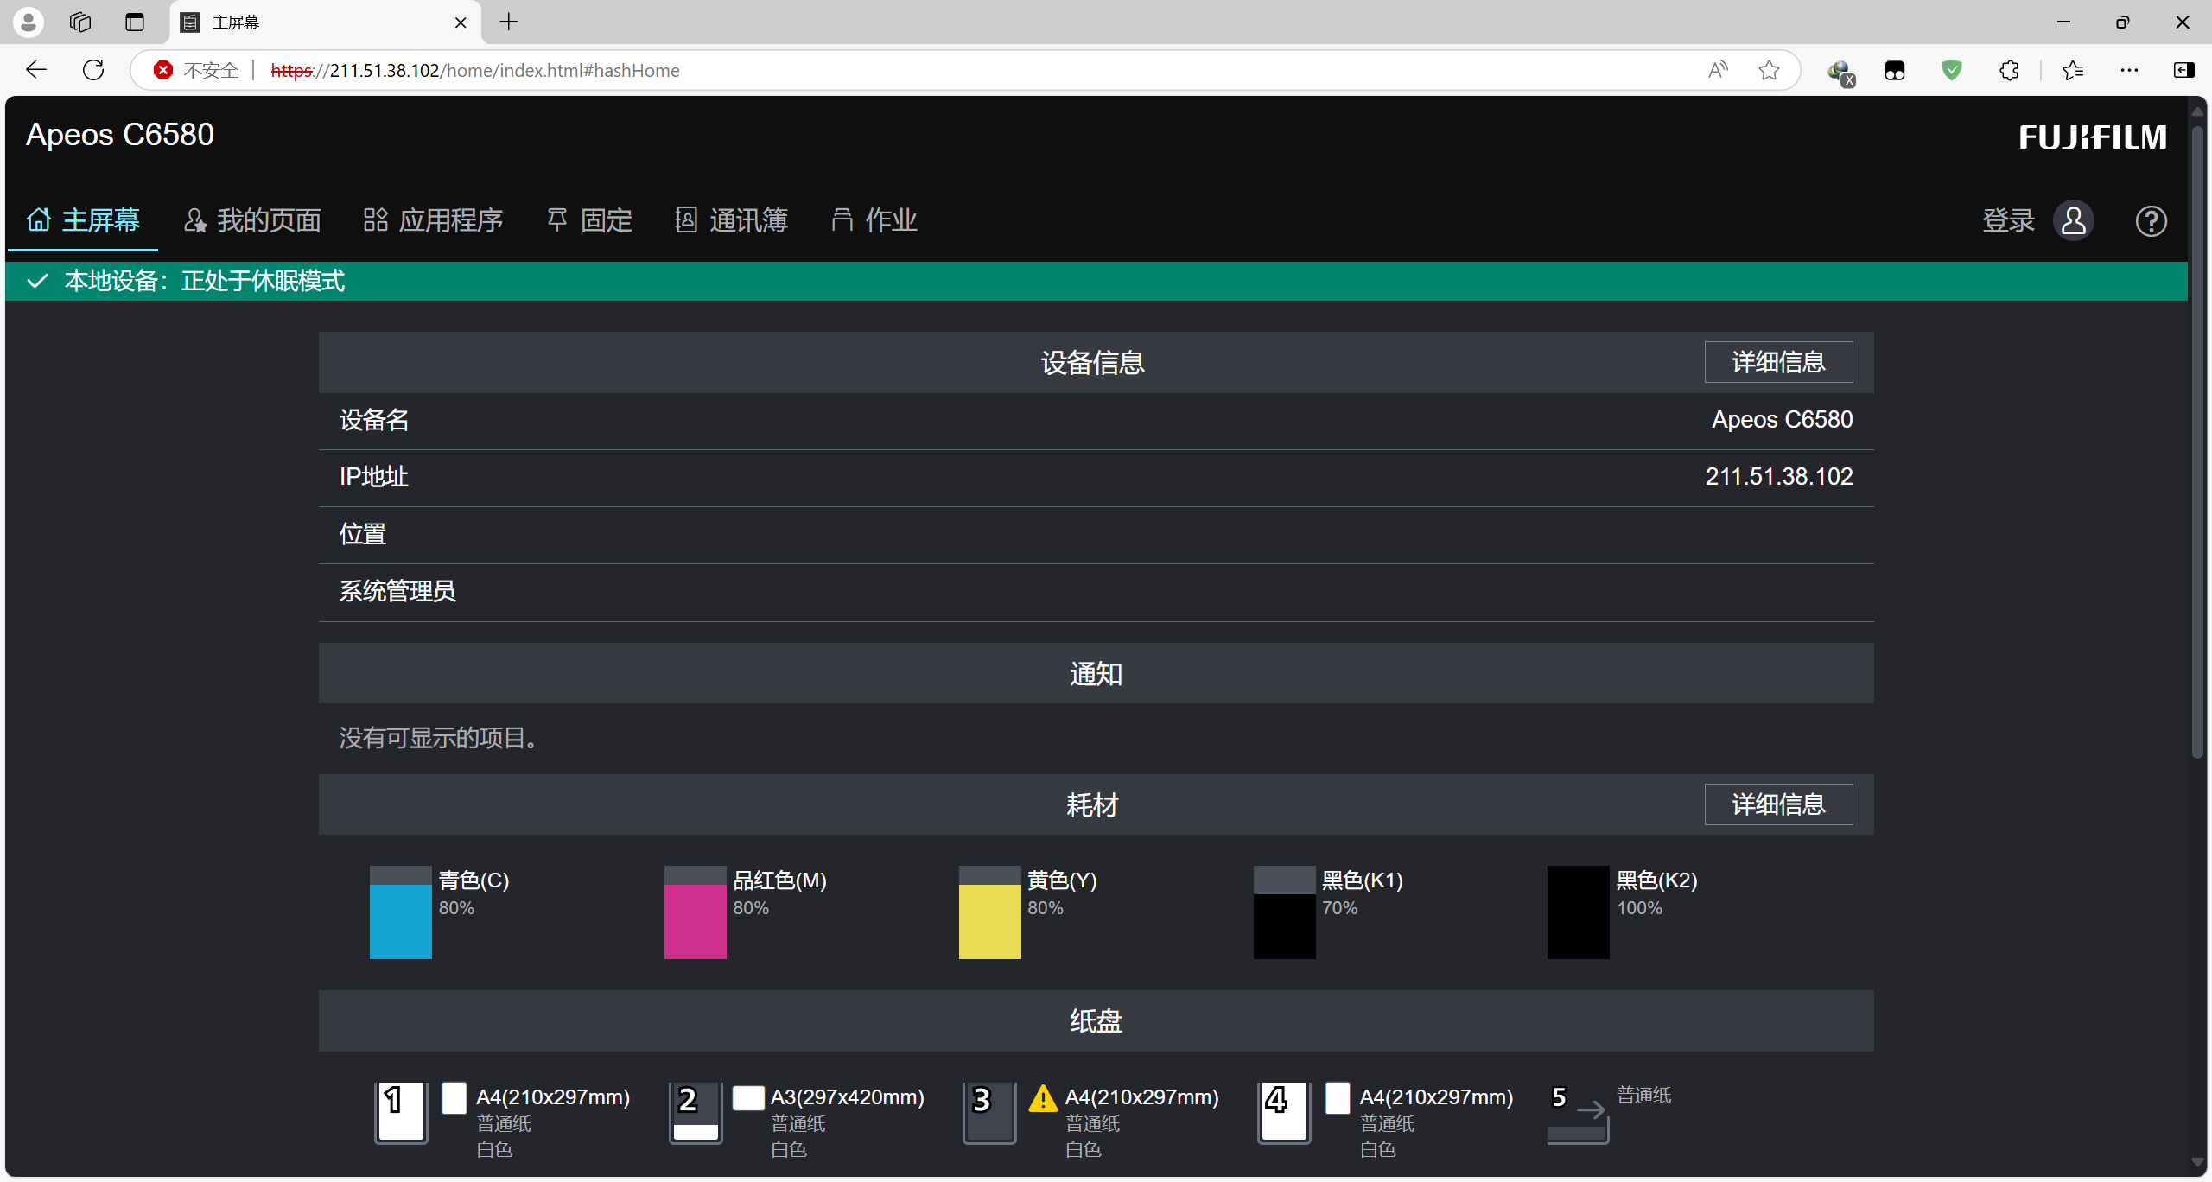

https://210.115.236.245/home/index.html#hashHome

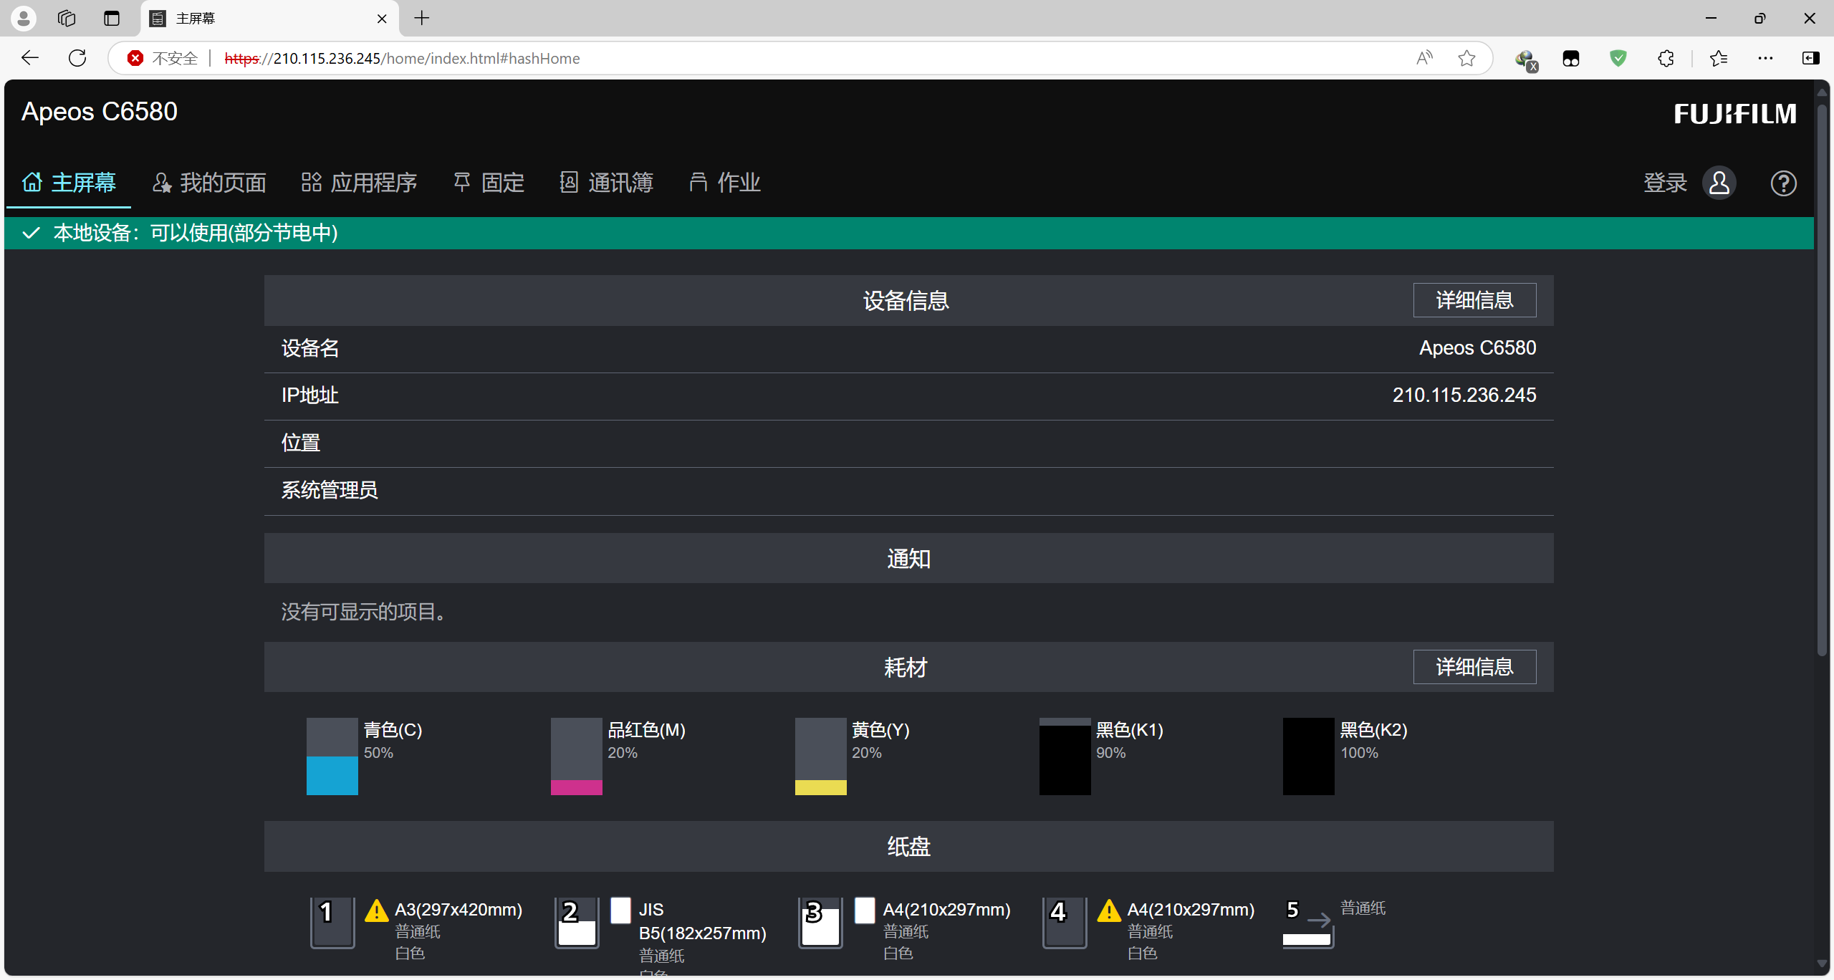

https://211.51.38.117/home/index.html#hashHome

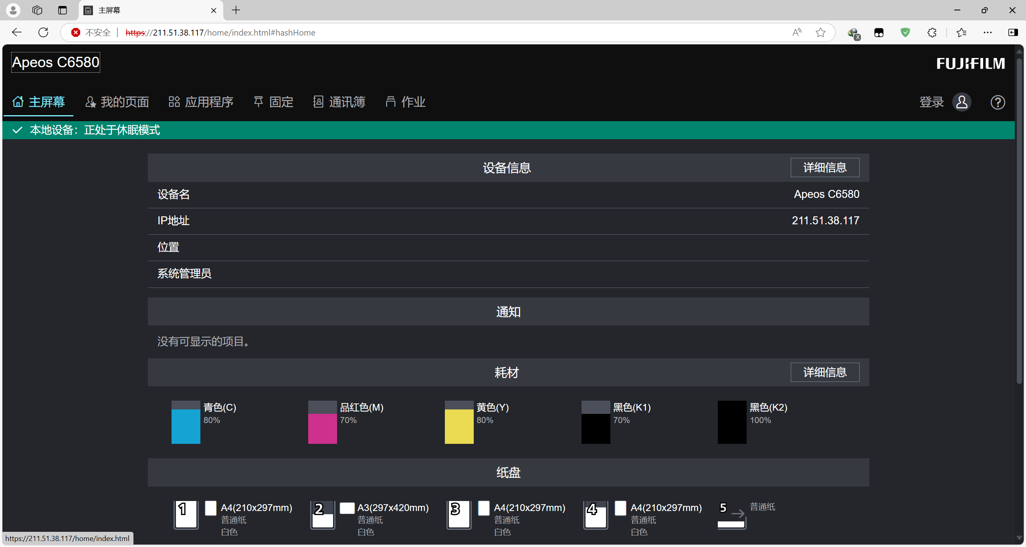

http://211.171.228.136/home/index.html#hashHome

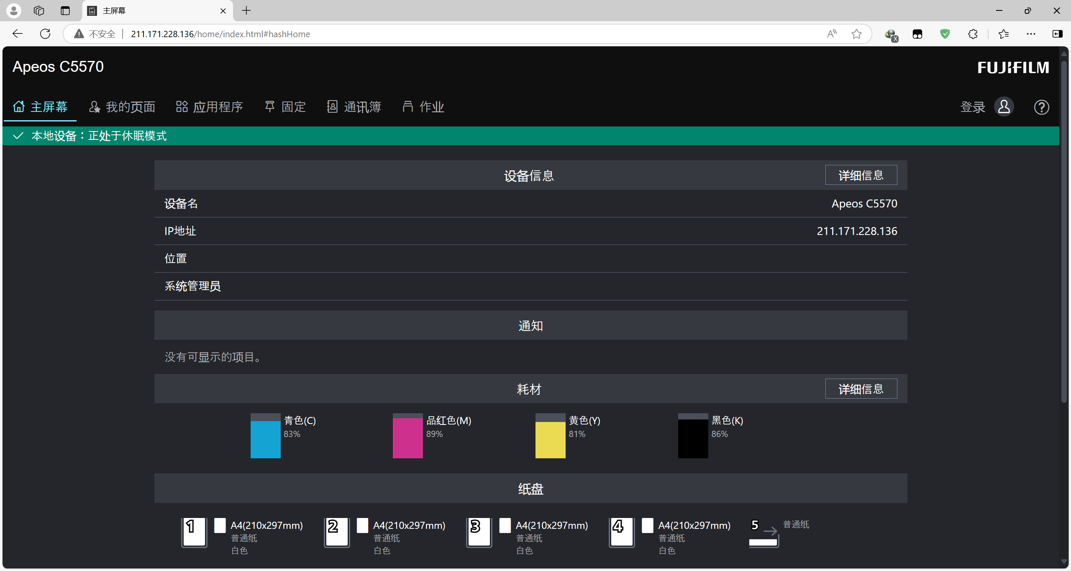

<https://211.51.38.113/home/index.html#hashHome>

